# **Assignment # 4**

**The Investment class:** Write a class called Investment with the following specification:

|  |
| --- |
| **Class: Investment** |
| **Attributes:** - balance : double - interestRate : double |
| **Methods:** + Investment() + Investment(balance : double, rate : double) + getBalance() : double + getInterestRate() : double + setBalance(balance : double) : void + setInterestRate(rate : double) : void + totalInterest() : double + totalInvestment(periods : int) : double + toString() : String |

Your class definition must contain all of the members listed in the specification exactly as they are defined.

The notes below will help you with the design of the Investment class:

Your class must work with the following test program (you may not change the test program in any way):

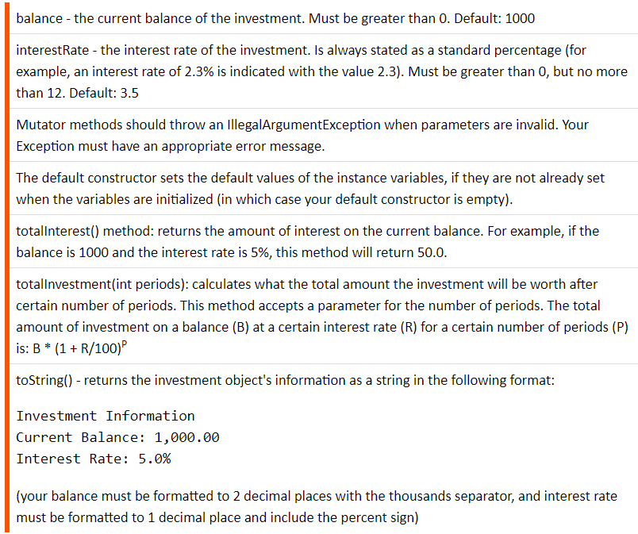

public class TestInvestment {

public static void main(String[] args) {

try {

Investment inv1 = new Investment();

System.out.println(inv1);

inv1.setBalance(10000);

inv1.setInterestRate(10.2);

System.out.println(inv1);

// uncomment this to test it (it should throw an exception):

//Investment inv2a = new Investment(0, 3);

// uncomment these lines to test them (last 2 lines should also

// throw exceptions):

//Investment inv2b = new Investment();

//inv2b.setBalance(-3);

//inv2b.setInterestRate(-3);

//inv2b.setInterestRate(12.01);

Investment inv3 = new Investment(2500, 7.9);

System.out.println(inv3);

double interest = inv3.totalInterest();

double total = inv3.totalInvestment(10);

System.out.printf("Total interest: $%4.2f%n", interest);

System.out.printf("Total investment: $%4.2f%n", total);

} catch (Exception ex) {

System.out.println(ex.getMessage());

}

}

}

**Do not submit the test program!**